
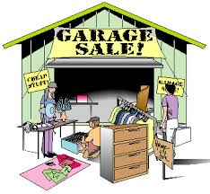

V
I
S
I
O
N
S

April 2014
Vol. XXXIV
No. 7
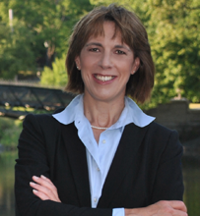
Wednesday, April 16, 2014

7:00

Stockade Building, Room 101

Schenectady County Community College

Speaker: State Senator Cecilia Tkaczyk
Topic: Women in Politics

Senator Tkaczyk has distinguished herself as a champion of education, as a fighter for people living with developmental disabilities, and as a strong advocate of helping small farms and businesses grow, expand, and create new jobs. In addition, she has worked hard to expand the role of woman in government.

She is the Ranking Member on both the Elections Committee and the Committee
on Mental Health and Developmental Disabilities. She also serves as a member
of the following committees: Agriculture, Environmental Conservation, Education,
Children and Families and Veterans, Homeland Security and Military Affairs.
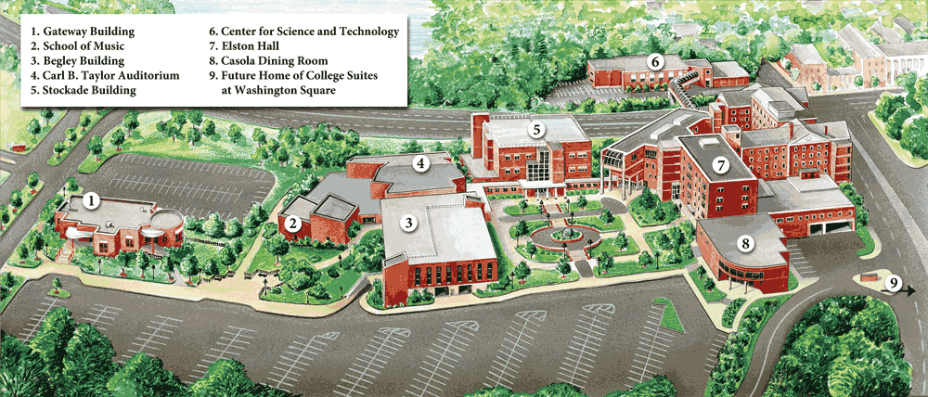

SCCC
Map
Parking Lot

Invite your friends and relatives to this very informative meeting.

Saturday, March 29  Princeton Review SAT Practice Test  at SCCC - Sponsored by AAUW  Wednesday, April 2  Board Meeting: 6:45 p.m.  Niskayuna Town Hall  Tuesday, April 8  Equal Pay Day – The symbolic day when  women’s earnings finally catch up  to men’s earning from the previous year.  Wednesday, April 16  General Meeting 7:00 p.m.  Stockade Building, Room 101  Schenectady County Community College  Friday-Sunday, April 25-27  AAUW NYS Convention, Ellenville, N.Y  www.aauw-nys.org/convention.htm | Wednesday, May 7  Board Meeting: 6:45 p.m.  Niskayuna Town Hall  Saturday, May 17  Niska-Day Plant Sale  Wednesday May 21  Annual Dinner at the Mohawk Club  Saturday, May 31  Garage Sale at Maxine’s house  Saturday, June 7  Kids’ Arts Festival, Jay St.  Schenectady  (More information next month.  Volunteers will be needed)





CO-PRESIDENTS’ MESSAGE

This is the 50th anniversary of President Johnson’s War on Poverty. According to the U.S. Census Bureau report for 2012, the number of people living in poverty was 46.5 million. The highest number seen in 54 years for which poverty estimates have been published. The condition of poverty is defined as being unable to meet the basic needs for food, clothing and shelter. Poverty guidelines are determined by the Federal government and for a family of four, the poverty threshold would be $23,850 a year. Poverty is a woman’s issue. Nearly six in ten poor adults are women, and more than half of all poor children live in families headed by women. Poverty rates are especially high for single mothers, women of color, and elderly women living alone.

AAUW is presently supporting two bills related to poverty that would benefit women:: The Fair Minimum Wage Act and the Paycheck Fairness Act. With today’s minimum wage stuck at $7.25 per hour, someone who works 40 hours a week, 52 weeks a year will take home less than $20,000 a year. That is below the poverty level for a family of four.

The War on Poverty is still going on and as we mark the 50th anniversary of the War on Poverty, there are actions we can all take now to help secure a strong economic future for all women and families—and join a legacy of AAUW members fighting for the same goal. We hope you sign up for the AAUW Action Network at www.aauw.org. so you can find out the latest ways to continue the War on Poverty and make your voice heard.

The Modern Literature group recently read Alex Kolowitz’s book, There Are No Children Here, which gave insight into the difficulties created by poverty through the lives of two boys living on Chicago’s west side. The group gained a new understanding of poverty and how difficult it is to escape its web.

Bobbi Richardson and Robin Eddy
Schenectady AAUW Proposed Officers for 2014-2015

Jennie Pennington and Arlene Maranville, Chairs of the Nominating Committee are pleased to present and nominate the following slate of officers for 2014-2015. They were endorsed at the AAUW Board meeting in March.
President Eleanor Aronstein

Program Vice-Presidents Jean Wildgrube and Bobbi Richardson

Secretary Jennie Pennington

Treasurer Linda Ward

Membership Vice-Presidents Pat Gregory and Arlene Maranville

AAUW Funds Vice-Presidents Miriam Cajuste and Maxine Borom

Public Policy Vice-President Linda Rizzo

Nominating Committee Pat Terry and Faith Weldon

Past Presidents Robin Eddy and Bobbi Richardson
Nominees for these elected offices will be voted on during the business section of the May 21, 2014 meeting. Other members of the nominating committee included Carol Reynolds, Jean Wildgrube, and Gail Karl.
Volunteers Needed for Children’s Plays
The Children's Plays committee is in need of additional members to help plan for a Theaterworks USA production to be performed in the Schenectady area. A tentative date in October has been secured, and an application for a Schenectady County (CIP) grant has been sent. However, we still need a coordinator and other volunteers to send out emails to teachers/administrators and to be in charge of collecting money for the tickets.

AAUW has a history of providing quality live theater entertainment to students in the past. We would like to continue this service, but will not be able to do so without a few more helping hands. If you are interested in volunteering, please contact Jackie Mendini (869-3816) or JAMendini@yahoo.com or Arlene Maranville (amarao41@aol.com). Thank you for your consideration. ~ Jackie Mendini
Education Equity

Education issues are even more complicated and depressing than usual. Underfunding has permeated every aspect imaginable, from the roll out of testing for the Common Core, to class size, to all-day kindergarten, to increasing pre-K.

Included, or perhaps a by-product of this mix, is the tug of war between Governor Cuomo and NYC Mayor DeBlasio over the role of charter schools, with the governor extremely supportive and the mayor fighting hard to get them removed, or at least greatly decreased in both number and influence. (It should be noted that most research now shows that charter schools do no better than public schools in the areas in which they are located and they DO siphon off funds, as they are presently financed in NYS.

One good source of information is Diane Ravitz, formerly a strong supporter of charter schools, who has come to the conclusion that she was wrong!)
Underlying the problem of underfunding is the failure of NYS to provide the money ordered by the courts as a result of the lawsuit won by the Campaign for Fiscal Equity against the state several years ago.
Please call your legislators NOW to remind them of their duty to provide the court-ordered funding. Schenectady is represented in the NYS Assembly by Angelo Santabarbara and Phil Steck. Both can be reached at 455-4100. Our Senator is Hugh Farley, who can be reached at 455-2800.

Maxine Borom


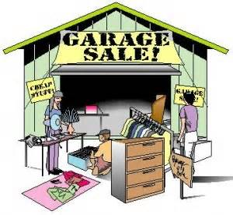
Our AAUW Garage Sale

Maxine Borom’s House
2171 Fox Hill Drive, Niskayuna

Saturday, May 31 9:00 a.m. – 3:00 p.m.
We will once again hold our popular garage sale. A time to rid your home of items that someone else will treasure. Your donated treasures could include household items, books, toys, games, jewelry and individually wrapped baked goods. We do not accept clothing. A lot of time could be saved if you would price your items before you bring them to the sale. It is always difficult to determine the value of an item, so pricing an item ahead would be appreciated.

Volunteers are needed for: Friday, May 30: Set-up starting at 1 pm.

Saturday, May 31: Sale day!

8:15 am – 10:45 am; 10:45 am – 1:15 pm; 1:15 pm – 3:30 pm (includes cleanup)

Let Pat Terry (rterry3@nycap.rr.com or 372-8431) know what slot you would like to volunteer. We also need several card tables to display items. Please drop these off at Maxine Borom’s home at 2171 Fox Hill Road (Orchard Park) Niskayuna. Items for sale may be dropped off at Maxine’s beginning in May.

This is a fun activity and we hope that many of you will donate items and volunteer to staff the event.


If you have items too large to transport to our garage sale and would like to donate them, contact Robin Eddy at 346-1683 or rjeddy321@gmail.com and she will list your items on Craigslist.

Money earned from this sale will be invested in our community projects, EOF and LAF.




Study and Interest Group Meetings for April 2014

If you’re interested in attending a meeting, contact the leader.

Book Exchange I
Leader: Dottie Potochnik (399-3854)
No regular meetings

Couples Gourmet
Leader: Jennie Pennington (372-7503)
Co-Leader: Jackie Mendini (869-3816)
Friday, April 11, 2014, 7:00 p.m.
Theme: French/Jacques Pepin
Hosts: Kay and Gene Stanczyk
Judy and Eric Block

Diverse Topics
Leader: Gail Karl (393-7590)
Monday, April 21, 2014, 1:30 p.m.
Program: "Guardian Help" - Women in the
Military & their transition into everyday life,
with Leigh Martin
Hostess: Robin Eddy
Location: 1222 Hempstead Rd, Niskayuna
Co-Hostess: Jane Jennings

Modern Literature
Co-Leaders: Joan Amell (399-4709)
Andrea Versaci (370-1455)
Monday, April 14, 2014, 7:30 p.m.
Book: The Dirty Life: On Farming, Food,
and Love by Kristen Kimbell
Reviewer: Barbara McEvoy
Hostess: Joan Amell
Location: 14 Marilyn Dr., Scotia
Co-hostess: Grace Mueller

Mah Jongg
Leader: Robin Eddy (346-1683)

Monday, April 14, 2014, 1:30 p.m.
Hostess: Maxine Borom
Location: 2171 Fox Hill Drive, Niskayuna

Monday, April 28, 2014, 1:30 p.m.
Hostess: Robin Eddy
Location: 1222 Hempstead Rd, Niskayuna
Quote of the Month

“Nothing is Impossible.
The word itself says
I’m possible!”

Audrey Hepburn

Look for this year’s

SPECIAL INCENTIVE

on the membership renewal form!
(see attachment)

Niskayuna Book Exchange
Leader: Ellie Rowland (250-4302)
No regular meetings

Quilting
Leader: Pat Terry (372-8431)
Monday, April 22, 2014, 7:00 p.m.
Program: Tie-In
Hostess: Marguerite Pileggi
Location: 3 Robin’s Nest, Niskayuna

Science Topics
Leader: Sally Dewes (346-1781)
Monday, April 7, 2014, 7:30 p.m.
Program: Presented by Ellie Rowland
Hostess: Sally Dewes
Location: 21 Englehart Dr., Glenville

Scotia-Glenville, Burnt Hills Varied Interests
Leader: Arlene Maranville (384-1639)
Co-Leader: Toni Walsh (372-8764)
Thursday, April 10, 2014, 12:30 p.m.
Program: “All about SCCC”
Speaker: Dr. Penny Haynes
Hostess: Pat Buczkowski
Location: 23 Haviland Dr., Scotia
Co-Hostess: Toni Walsh
Serendipity
Co-Chairs: Jennie Pennington (372-7503)
Reba Mehan (374-7886)
Next program TBA

Word Games
Leader: Eleanor Aronstein (518-265-2500)
Tuesday, April 15, 2014, 3:00 p.m.
Hostess: Eleanor Aronstein
Location: 909 Londonderry Court, Schenectady

Congratulations
AAUW Schenectady Branch!

Our branch won a $500 award
from Walmart for the work
we are doing in the community!

