

February’s General Meeting

V
I
S
I
O
N
S

February 2014
Vol. XXXIV
No. 5
Wednesday, February 19, 12:00 p.m.
Casola Dining Room - Schenectady County Community College
78 Washington Avenue, Schenectady

Enjoy gourmet dining prepared by SCCCs culinary students

Theme: A Greece/Eastern Mediterranean Luncheon
Appetizers
- Avgolémono Soup - Traditional Greek soup made with chicken broth, lemon, egg yolks, and rice Garnished with julienne of chicken breast and chives
- Spanakopita - Savory Greek pastry, stuffed with spinach, onions, ricotta, romano and feta cheeses, scented with dill and mint served with red pepper coulis and dill sauce
- Greek Salad - Mixed field greens tossed with tomatoes, feta cheese, cucumbers, tabbouleh, kalamata olives topped with anchovy fillets and dressed with Greek salad dressing
- Bread: Pita Bread accompanied by Hummus and Baba Ghanoush
Entrées
- Shish Kebab Marinated lamb and vegetable skewers accompanied by Moroccan couscous, moussaka, and tzatziki
- Kota Kapama Breast of chicken braised in a tomato and cinnamon sauce accompanied by Moroccan couscous and moussaka
- Tagine of Monkfish Monkfish rubbed with a Mediterranean herb rub braised in a saffron-infused broth with fresh fennel, tomato and preserved lemon
Desserts
- Baklava Flaky filo pastry layered with a spiced nut mixture drizzled with honey-lemon syrup
- Revani Brandy and almond caked moistened with spicy orange syrup
- Poached Figs and Honey Ice Cream Figs poached in a sweet red wine, served with a sesame tuille and honey vanilla ice cream
Cost: $16

RSVP by February 4th to Ellen Auerbach at ellenmtauerbach@gmail.com or 381-4432
Mark Your Calendar
Tuesday, February 4  The last day to submit an entry for  AAUW’s art show - Information on page 5.  Saturday, February 8 - Sat. March 8  Vote for your favorite artwork on www.aauw.org  Wednesday, February 5  Board Meeting: 6:45 p.m.  Niskayuna Town Hall (second floor)  Wednesday, February 19  General Meeting: 12:00 p.m.  Casola Dining Room  Schenectady County Community College | Wednesday, March 5  Board Meeting: 6:45 p.m.  Niskayuna Town Hall (second floor)  Thursday, March 13  General Meeting: 1:00 p.m.  Program: America’s 9 first ladies  from New York State  Speaker Elizabeth Kaplan  NY Council for the Humanities  Location: McChesney Room,  Schenectady County Public Library



CO-PRESIDENTS’ MESSAGE

A VERY Successful Event at Schenectady County Community College
AAUW FINALS WEEK SURVIVAL CARE BAGS

When Bobbi Richardson said at our November board meeting that she was going to send a box of goodies during finals week to our June, 2013 AAUW high school scholarship winner, Miriam Cajuste, our AAUW Funds VP, immediately said, let’s also do it for our local community college students and hopefully have them sign up as e-affiliate students. (Schenectady County Community College had already joined AAUW as a college partner.) So began our AAUW FINALS WEEK SURVIVAL CARE BAGS!

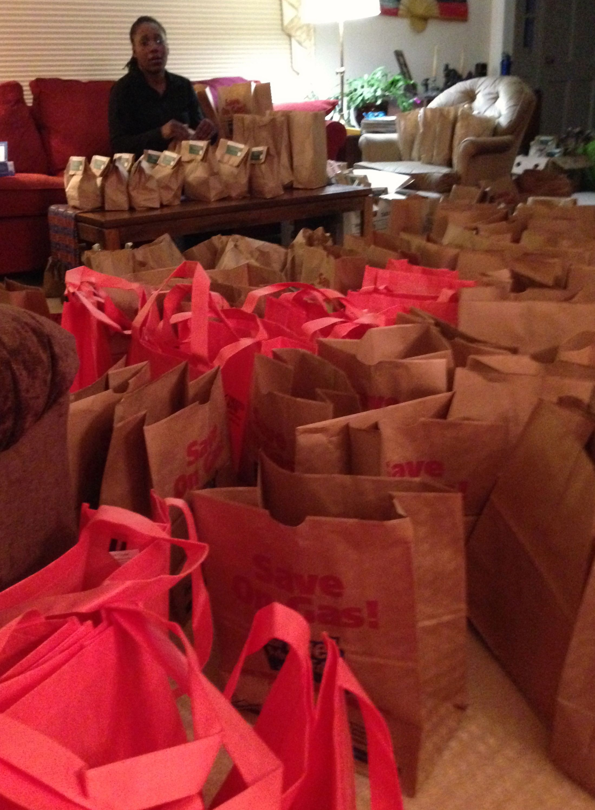
Miriam and Robin applied for and received donations from Stewarts, ShopRite, Hannaford, Walmart, Target, Trustco Bank, an especially generous donation from Price Chopper, and from our members Ann Hicks,
Ann Bish, Betty Rose, Carolyn Montorio, Dottie Potochnik, Faith Weldon, Ellie Rowland, Linda Ward,
Robin Eddy, Suzanne Taylor, Pat Terry, Sally Dewes and Susie Leon.

Linda Ward, Sally Dewes, Miriam Cajuste and Robin Eddy packed 400 bags with an apple or orange,
a fruit bar, single servings of fruit cocktail or applesauce, an envelope of hot chocolate mix, a Milky
Way and Twix bar and a baked good. The bags were stapled with our AAUW Schenectady Branch
business card on one side and on the other side of the bag we wrote AAUW in big letters with a bright red marker.

For the 2 day event, December 17th and 18th for 2 hours each day, we filled a table near the longue and cafeteria with our bags and put up 2 of our banners. With the help of Arlene Maranville, Barbara Aldi, Miriam Cajuste, Pat Gregory (who drove to the college from Saratoga on a snowy morning), Robin Eddy and Susie Leon, we passed out our AAUW bags along with a drink. As the students stopped by, we explained what AAUW was, how AAUW could benefit them and wished them well on their exams. We had forms that the students could fill out if they were interested in becoming e-student affiliates.

The bags and drinks that were left over were donated to the City Mission for their community food program.
We had 218 students fill out the form and several teachers filled out another form.

This was a very successful event thanks to our members who donated items, helped pack the bags and/or helped at the college. The event was greatly appreciated by the SCCC’s administrators and the president of the college. The businesses that donated items also thought it was a special thing to do for the students during finals week. We had great conversations with many of the students (yes, some students naturally just stopped by for the free food).

A very special added bonus was that a Babette Faehmel, a women’s studies professor at SCCC, after hearing about AAUW and its mission, agreed to start an AAUW group at the college!

Other activities during the month of December included our participation in the Festival of Trees. Thank you to Jackie and Bruce Mendini who put up, decorated, and took down the tree at the YWCA. Thank you also to members of the Quilt group who provided ornaments. The theme was AAUW Soaring to New Heights. This is another example of our visibility in the community.
We did indeed send an exam survival box to Tusha Ramnarine, our Schenectady High School scholarship recipient at SUNY New Paltz. We received a lovely thank you note saying that the arrival of the box made her smile. We are looking forward to a productive year ahead.
Bobbi Richardson roberta_richardson@hotmail.com and Robin Eddy rjeddy321@email.com
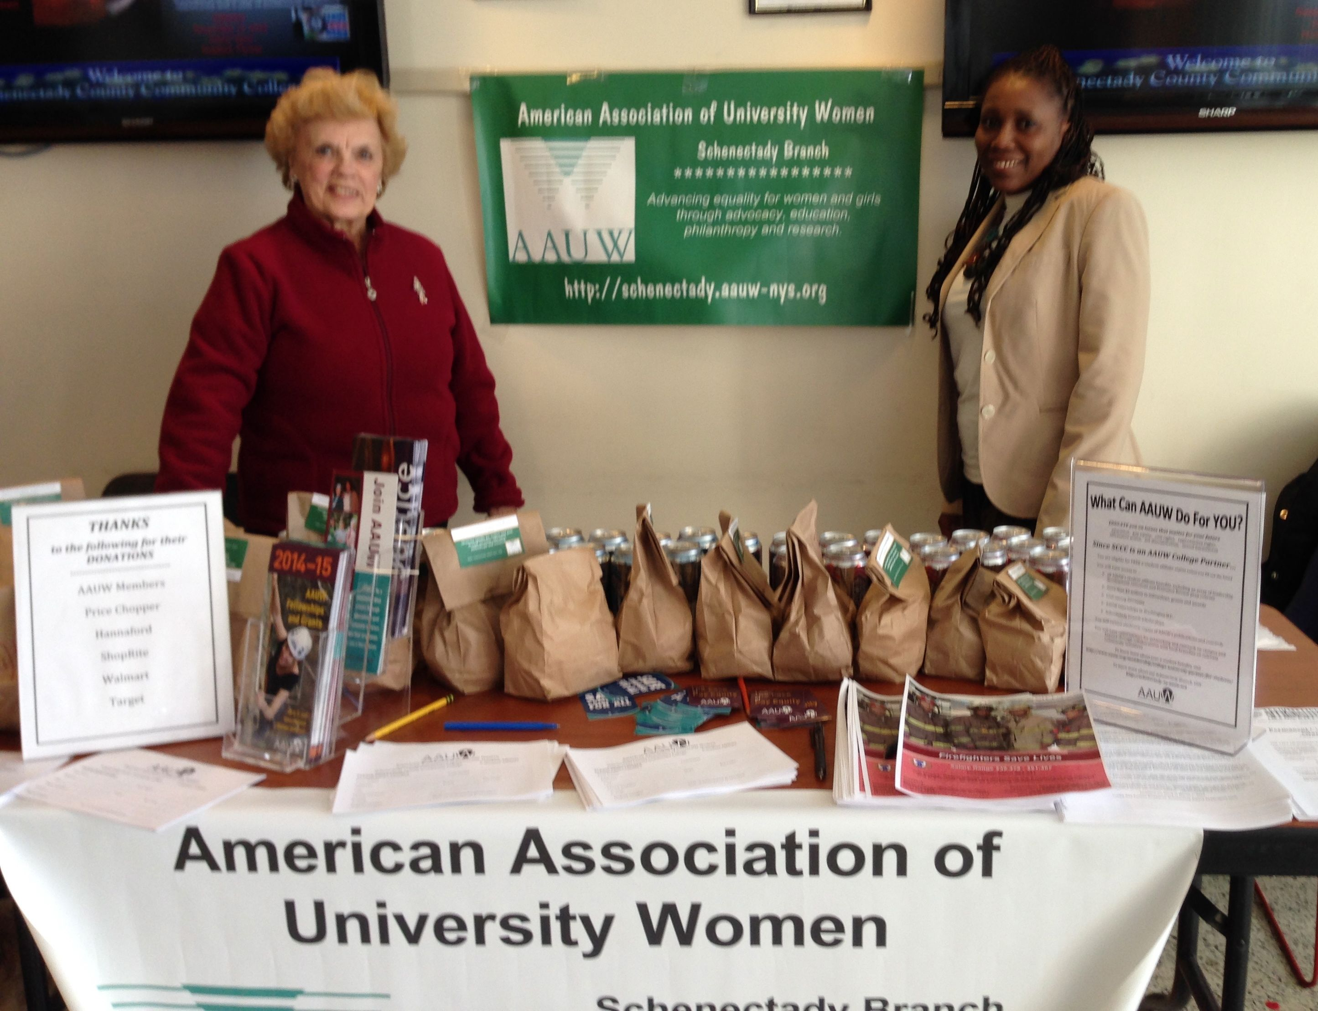
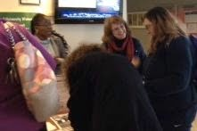

AAUW recognizes Schenectady’s SCCC student recruitment program
The AAUW e-newsletter, Membership Matters will contain an article by Robin Eddy on the success of recruiting students at our AAUW Finals Week Survival Care Package Event in December at SCCC. AAUW noted the success of the event and asked Robin to write an article for this publication to be published at the end of January and will be available online.

MEMBERSHIP NEWS

Happy New Year to All! In keeping with the theme of “new beginnings,” we want to remind you of the Member Get a Member Campaign; AAUW has so many networking and mentoring opportunities, and stressing these positives may lead to a reward – a commemorative pin for a person who has recruited five or more people – yes, it has happened! Also, the week-long AAUW Tech Trek camp for rising eighth-graders to promote STEM interest has been featured on the CBS Evening News. Some branches sponsor a student’s trip, but so far the sites have been far afield from NYS (Oregon, New Mexico, and Alabama this year).
Let’s try to make our AAUW dreams and goals come true this year.
Carolyn Montorio and Pat Gregory

PLEASE UPDATE YOUR DIRECTORY
Ellie Rowland has moved to 216 Lois Lane, Niskayuna. New Phone No. 250-4307

Carol Reynold’s e-mail address should be corrected to read Carolfreynolds@gmail.com.

PROPOSED BYLAW CHANGES, JANUARY, 2014

- Change Article XI, Section 1b to read “There shall be a minimum of two meetings each year to carry on the business of the Branch.
- Change Article V, Section 2 to read “Election of Branch officers shall be held at the May General Meeting.”

In accordance with Article XVI, Section 3, these changes are proposed 30 days in advance and will be voted on at the next General Meeting of the membership.

Jennie Pennington, Bylaws Chair

Public Policy: SEXUAL HARASSMENT SHOULD NEVER BE TOLERATED

AAUW has been empowering women since 1881. It has addressed the issue of sexual harassment through its advocacy fund and programs.

In the past, the organization has taken individuals to task such as Rush Limbaugh for using derogatory slurs against women. Through its advocacy programs, it has helped women not to overlook any aspect of sexual harassment. Equity for women has been a major focus of AAUW.

During the week of January 6, Rush Limbaugh made another crude comment about women. Being misogynistic is a way of life for this "radio talk show host." He mocked individuals for criticizing men who inappropriately look at women classifying them as liberals. Some may believe that his remarks are not sexual harassment, but rather "crude locker room" talk. The issue is not how his remarks should be classified, but rather the underlying disrespect for women that they display. Prominent individuals such as Limbaugh should never cross the line of being derogatory toward women. Of course, he is not the only prominent individual to be guilty of this action. Martin Bashir, a commentator for MSNBC, was removed from his television show for making a vile comment about Sarah Palin. Making a vile comment about any woman because you do not agree with her political opinion is wrong. Both sides of the political aisle should show indignation regarding this type of behavior.

Women were not allowed to vote until 1920, and they suffered great pain to gain this right. In 2014, women still are not receiving equal pay. The Women Equity Act failed to pass the New York State Senate last year. Will it finally pass in 2014? It seems women need to be vigilant about protecting their rights on all levels. Hopefully, we can stop derogatory rhetoric against women by making our voices heard. Alone we are weak, but together we can make a difference.
Linda Rizzo

As we develop our leadership team for 2014-2015, the Nominating Committee needs to know of your interest in becoming part of a dynamic Board of Directors with a vital mission. Equity is still an issue, and its relevance to our region is vital.

If you might be willing to become part of the leadership team,
please contact Jennie Pennington (372-7503) or Arlene Maranville (384-1639) to discuss.

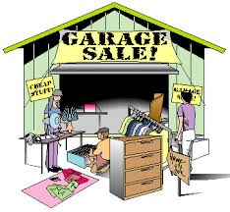
OUR SPRING GARAGE SALE

The Branch will be holding a garage sale in the spring at the home of Maxine Borom,
2171 Fox Hill Drive, Orchard Park, Niskayuna. Please save gently used items for this event,
no clothing. We will list drop off spots in the March issue of Visions. Anyone who would
be willing to store items until the sale, call Bobbi Richardson (346-6697) or Pat Terry (372-8431).
This has always been a fun activity and a great way to interact with our fellow members.
We haven't decided on a date yet, but it will be before Niska Day.

Quote of the Month

"For most of history, Anonymous was a woman."
Virginia Wolff

Volunteer Opportunites

- Things of My Very Own, Org.: Rayn Bouncie, our December Luncheon speaker, said that she could use volunteers to help sort clothes. If you are able to give 1-2 hours weekly or even once a month to this important community organization, contact Robin Eddy, rjeddy321@gmail.com or 346-1683. To find out more about what this organization is doing, check out and follow their postings at https://www.facebook.com/thingsofmyveryown

- Life Unplugged 2014 – Helping students become aware that the choices they make today can impact their life goals and responsibilities in the future.

Saturday, March 8, 2014
Schenectady County Community College

The program is free and open to High School Sophomores, Juniors, and Seniors

Life Unplugged is an active, hands-on, real-life simulation that gives students the opportunity to explore career opportunities and make lifestyle and budget choices similar to those adults face on a daily basis.

Participants assume that they are 25 years old and have completed basic educational requirements for their occupation. Students then draw a family status; some students may not have any children while others may have up to 5 children.

Students will then visit at total of 15 booths where representatives from various agencies - including the housing industry, banking institutions, utility com-panies, auto dealerships, and child-care centers – will help them determine how much of their incomes must be spent to meet their wants or needs.
For more information visit their website: http://www.schenectadybpw.org/events/youth-leadership

Contact: Miriam Cajuste at mkajust@gmail or 894-3852 to volunteer or sponsor a booth.

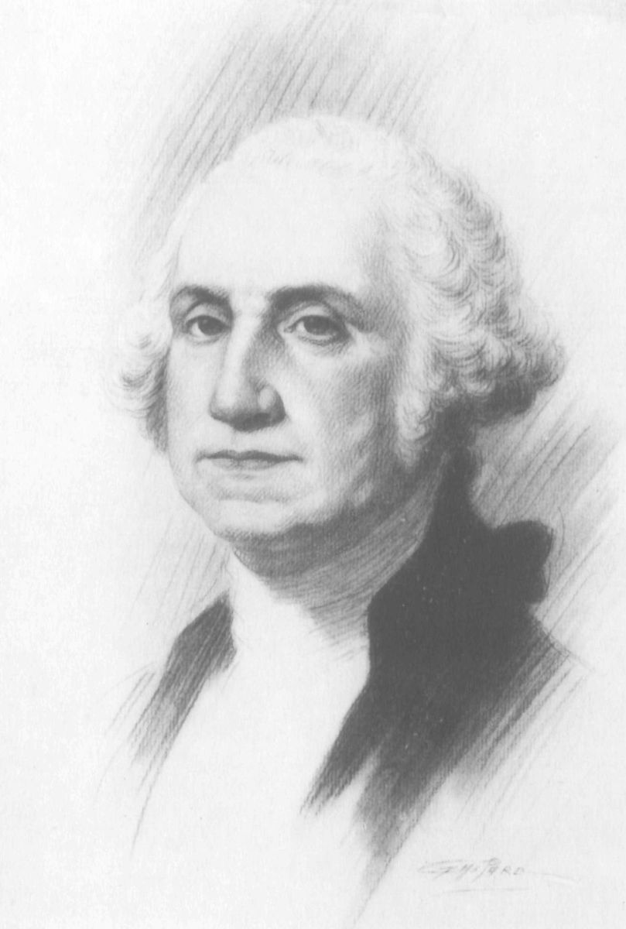
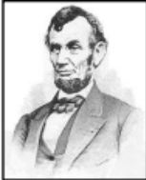

Study and Interest Group Meetings for February 2014

If you’re interested in attending a meeting, contact the leader.


Book Exchange I
Leader: Dottie Potochnik (399-3854)
No regular meetings

Couples Gourmet
Co-Leaders: Jennie Pennington (372-7503)
Jackie Mendini (869-3816)
February 14, 2014
Theme: Ladies’ Lunch at Garden Bistro 24
Organizer: Jackie Mendini

Diverse Topics
Leader: Gail Karl (393-7590)
February 17, 2014, 1:30 p.m.
Program: Ellis Medicine - General Operation" with
Patti Hammond, V.P. of Physicians Services
Hostess: Ellie Rowland
Location: 216 Lois Lane, Schenectady

Mah Jongg
Leader: Robin Eddy (346-1683)
February 10, 2014, 1:30 p.m.
Hostess: Ellie Rowland
Location: 216 Lois Lane, Niskayuna
February 24, 2014, 1:30 p.m.
Hostess: Bobbi Richardson
Location: 1417 Fox Hollow Road, Niskayuna

Modern Literature
Co-Leaders: Joan Amell (399-4709) and
Andrea Versaci (370-1455)
February 10, 2014, 7:30 p.m.
Book: Prayers for Sale by Sandra Dallas
Reviewer: Grace Riccobono
Hostess: Toni Walsh
Location: 113 Alexander Avenue, Scotia

Co-hostess: Mary Delory

Niskayuna Book Exchange
Leader: Ellie Rowland (250-4302)
No regular meetings

Quilting
Leader: Pat Terry (372-8431)
February 25, 2014, 7:00 p.m.
Program: Apron Project/Vacation Inspiration
Hostess: Toni Walsh
Location: 113 Alexander Avenue, Scotia

Science Topics
Leader: Sally Dewes (346-1781)
February 3, 2014, 7:30 p.m.
Program: “Bees” presented by Sally Dewes
Hostess: Ellie Rowland
Location: 216 Lois Lane, Schenectady, NY 12304

Scotia-Glenville, Burnt Hills Varied Interests
Co-Leaders: Arlene Maranville (384-1639)
Toni Walsh (372-8764)
February 13, 2014, 12:30 p.m.
Program: History of Womens’ Clubs
Presenter: Toni Walsh
Hostess: Reba Mehan
Location: 134 Glen Eddy, Niskayuna
Hostess: Susie Leon

Serendipity
Co-Leaders: Jennie Pennington (372-7503) and
Reba Mehan (374-7886)

Word Games
Leader and Hostess: Eleanor Aronstein (518-265-2500)
February 12, 2014, 2:00 p.m.
Location: 909 Londonderry Court, Schenectady



AAUW National is having their annual art contest. This contest is a great way for AAUW members to showcase their talent. Our own Faith Weldon won the contest in 2012.

From January 4 to February 4, AAUW members may submit an electronic version of a design on the AAUW Art Contest webpage at www.aauw.org. Submissions can be photography or a digital photo of your painting, drawing, sculpture, collage, or other form of artwork.

AAUW members will be asked to vote for their favorite entries beginning February 8 and continuing through March 8. Members may vote once every seven (7) days for their six (6) favorite images.

Six images selected by members and judges who previously won the contest will appear on note cards that will be mailed to tens of thousands of AAUW members across the country this spring. Three images will be chosen by member votes, and the judges will select three. We hope you will consider participating in this year’s contest and encourage your AAUW friends to do the same. All contest details can be found on AAUW National’s website www.aauw.org.

AAUW
Schenectady Branch
C/O Linda Zuckerman
1137 Fernwood Drive
Niskayuna, NY 12309

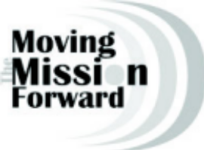

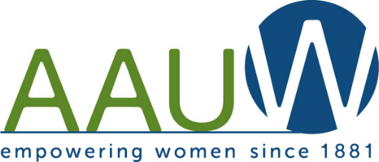

VISIONS

Schenectady Branch Newsletter AAUW
(published monthly except
January, July, August)

The deadline for newsletter items is the

1st week of the month

prior to publication.

Editor Linda Zuckerman

Circulation: Reba Mehan

Co-Presidents

Bobbi Richardson and Robin Eddy

Website: schenectady-ny.aauw.net

AAUW's Mission

AAUW Advances Equity for women through advocacy, education, philanthropy and research.

AAUW's Vision

AAUW will be a powerful advocate and visible leader in equity and education through research, philanthropy, and measurable change in critical areas impacting the lives of women and girls.

AAUW's Promise

By joining AAUW, you belong to a community that breaks through educational and educational barriers to so that all women have a fair chance.

In Principle and in Practice AAUW Values and seeks diverse membership.

There shall be no barriers to full participation in this organization on the basis of gender, race, creed, age, sexual orientation, national origin, disability or class.

