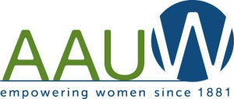

November's General Meeting

Wednesday, November 20

6:30 p.m. (note earlier time)

McChesney Room, Schenectady County Public Library

Program: A Woman's Perspective As A Military Nurse In Afghanistan

Speaker: Major Sharon Westbrook

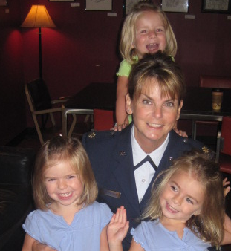

Major Sharon Westbrook is an Air Force veteran, registered nurse, wife
and mother. She currently works for both Ellis Hospital in Schenectady
(as a civilian RN), and the Stratton Air National Guard Base in Glenville.

At Stratton, she is the Officer in Charge of the Stratton Medical Clinic
Mobile Aeromedical Staging Facility, responsible for training and preparing
her unit to be able to deploy and operate a mobile medical facility with
great efficiency when necessary in a combat or natural disaster situation.

This meeting is to the Public! Invite your friends and relatives!

V
I
S
I
O
N
S

November 2013
Vol. XXXV No.3

Mark Your Calendar

Tuesday, November 5
ELECTION DAY
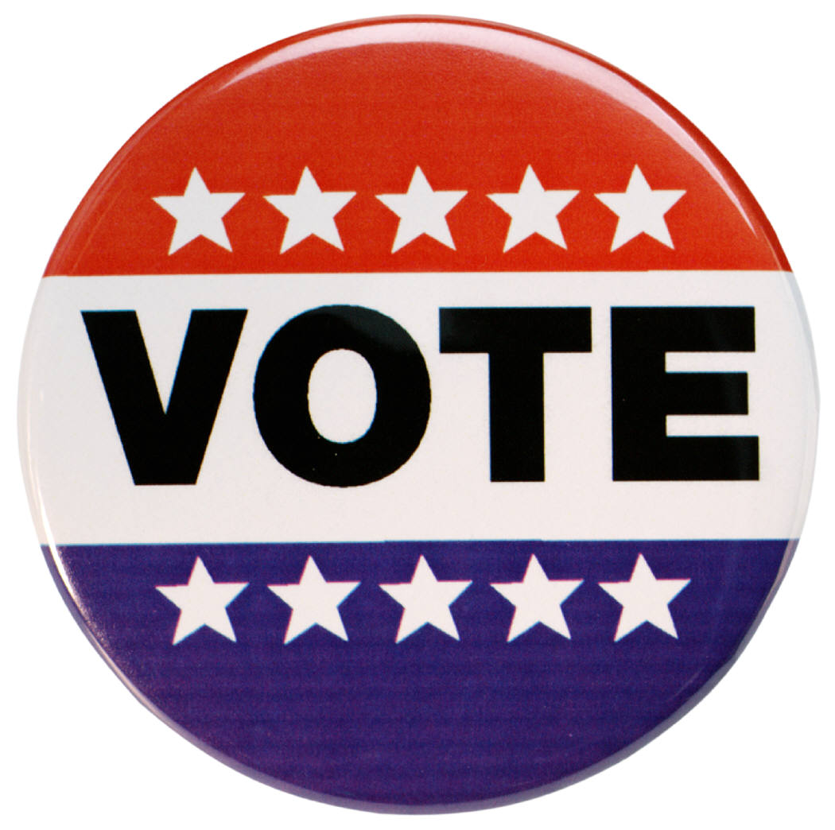

AAUW volunteers who are
collecting election results
should arrive at the polling
location at about 8:45 pm.

Wednesday, November 6
Board Meeting 6:45 p.m.
Niskayuna Town Hall (2nd floor)

Wednesday, November 20
6:30 (note earlier time)
General Meeting

Thursday, November 28
November 30
Registration for Luncheon DUE

December
No Board Meeting in December

Saturday, December 7
Luncheon at the Mohawk Golf Club



CO-PRESIDENTS’ MESSAGE

October was chock full of informative, interesting and fun programs. We had much to participate in, from an international focus to a local one. Our general meetings are an opportunity to see other AAUW members who are not in our interest group(s). If you haven’t joined us for a general meeting in a while, plan on joining us this month to hear Major Sharon Westbrook as she relates her experience as a military nurse in Afghanistan. It will be a very interesting follow-up after hearing Malalai Joya, the activist, writer and former politician from Afghanistan we heard at our October program in Albany.

As a result of our September program with Chris Parsons, who is one of our new members, we will be collecting items at our December luncheon for City Mission that would benefit women in our community who are trying to establish themselves in the work place and become self-supporting. We will also be collecting items for children helped by Things of My Very Own, Inc.

Once again we will be collecting election results on Election Night, Tuesday November 5th. This is how we pay for the Candidates’ Forums and television coverage that we co-sponsor with the League of Women Voters. Getting the results usually takes about an hour or less of your time which includes going to a poll site, copying down the results of the vote and then calling the totals into The Capital District Election Service. If you collected last year you can do the same site again. We could use more poll collectors. Two people can go together. Please contact either Bobbi or Robin if you can help.

We hope you will check out AAUW’s Two-Minute Activist. You can access it from the right side column of our website at http://schenectady-ny.aauw.net/. This is an easy and important tool you can use to stay informed on important issues. If you choose to make your voice heard, AAUW has sample letters on the site that you can submit to your congressmen as is or edit to express your opinions.

Hope to see you at our November General Meeting,

Bobbi Richardson roberta_richardson@hotmail.com and Robin Eddy rjeddy321@gmail.com

MEMBERSHIP

November with all its beauty and familial traditions is here. It’s especially a time to be thankful for being a part of AAUW and its mission of advancing equity for women and girls through advocacy, education, philanthropy and research.

AAUW continues to support legal cases; and one recent victory is Parker v. Indiana High School Athletic Association. Amber Parker and Tammy Hurley successfully fought for fairer scheduling of varsity girls’ basketball games in Franklin County, Indiana. It is important to celebrate every success in women’s struggles against unfairness. And this month of thankfulness is an opportune time to invite friends and relatives to join us at a general meeting.

Remember that anyone who becomes a member at one of our meetings gets a discount in dues!

Pat Gregory and Carolyn Montorio

Welcome to AAUW-Schenectady!

Eleanor Aronstein

909 Londonderry Court
Schenectady, NY 12309
845-462-6542 (home) 518-265-2500 (cell)
eleanoraronstein@aol.com

Eleanor was a member of the Poughkeepsie Branch.

(Please add Eleanor’s information to your directory.)
Quote of the Month

I am only one, but still I am one.
I cannot do everything,
but still I can do something;
and because I cannot do everything
I will not refuse to do the something
That I can do!

Helen Keller
(Helen was 75 when she published
her famous book, Teacher.)

AAUW PUBLIC POLICY FOCUS FOR 2013

AAUW is committed to promoting women’s issues through its public policy program. “The public policy program underscores AAUW’s mission of advancing equity for women and girls through advocacy, education, philanthropy, and research” (AAUW, 2013). The organization informs its members of important policy issues so that they are able to support these issues on the local, state, and national levels. “Issue advocacy isn’t just about AAUW lending its name to an issue, or speaking on Capitol Hill. Issue advocacy is about AAUW members and all citizens concerned with equity being knowledgeable and aware of the current status of important issues” (AAUW’s FEDERAL POLICY AGENDA, 2012). It is important to note that AAUW has been concerned about the U.S. government shut down and its effect on women and women’s issues. For instance, the closing of head start programs for young children has had an impact on many low income families. Also, health care clinics funded in part by the government have been closed placing an additional burden on families in need of these clinics.

AAUW’s public policy issues cover several important areas. These policy issues are: 1) education is the foundation of our society; 2) all individuals need to have affordable housing, health care, and a clean environment; 3) all individuals have a right to privacy, freedom from violence, and reproductive rights; 4) affirmative action is essential to the well-being of people throughout the world; 5) more international policies to promote human rights, and justice; 6) pay equity and fairness in compensation for all women; 7) the protection of social security from privatization; 8) the improvement of retirement benefits; 9) the vigorous protection of and full access to civil and constitutional rights; 10) strong enforcement of employment antidiscrimination statutes. Several of these policy issues could be in jeopardy if the government shut down continues for a long period of time.
The biennial action priorities included the support of a strong public school system, the economic self-sufficiency of all women, and the guarantee of equality, individual rights, and social justice for a diverse society.

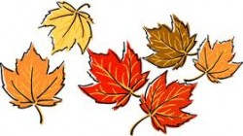
Social security, Medicare, and Medicaid continue to need our support in 2013. These entitlement programs are essential for a large segment of our population. AAUW will be a major player in supporting these important programs since it advocates for economic self-sufficiency of women. In addition, there will be continued focus on fair pay for women. This issue still has not been resolved on the federal or state level. AAUW will continue to lobby state and national leaders to pass this legislation so that women receive the same pay as men for doing the same job.

One way to have a voice and to support AAUW public policy issues is to vote at election time. So remember to vote this November. Let your voice be heard! Linda Rizzo

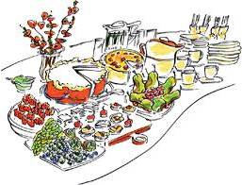
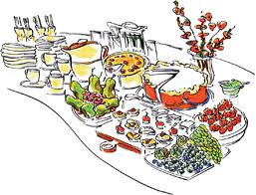
Join us for at our

Annual December Luncheon

Mohawk Golf Club

December 7, 11:30 a.m.

Please make your check out to AAUW-Schenectady Branch in the amount of $25.
Mail to: Ellen Auerbach, 848 Beech Drive, Niskayuna, N.Y. 12309 by November 30.

Circle your choice of entree: Chicken Marsala London Broil Herb Crusted Salmon

Name: ________________________________________________________

As we have done in the past, we will be collecting donations to 2 local charities.

City Mission - personal care and household items http://citymission.com/?page_id=762

Things of My Very Own, Inc. – school supplies, toys, pajamas, personal care items http://tomvo.org/our_wish_list

For more information about these charities and items on their wish lists, check out their web sites.

Study and Interest Group Meetings for November 2013

If you’re interested in attending a meeting, contact the leader.

Book Exchange I
Leader: Dottie Potochnik (399-3854)
No regular meetings

Niskayuna Book Exchange
Leader: Ellie Rowland (370-1958)
No regular meetings

Couples Gourmet
Leader: Jennie Pennington (372-7503)
Co-Leader: Jackie Mendini (869-3816)
November 8, 2013, 7 p.m.
Theme: Cooking Light
Co-Hostesses: Betty & Bob Rose
Kay & Gene Stanczyk

Diverse Topics
Leader: Gail Karl (393-7590)
November 18, 1:30 p.m.
Program: Hospice / Jane Nicole Prince Home
Paula Symanski, Speaker
Hostess: Robin Eddy
Location: 1222 Hempstead St., Niskayuna
Co-Hostess: Susie Leon
Modern Literature
Co-Leaders: Joan Amell (399-4709)
Andrea Versaci (370-1455)
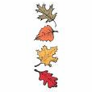
November 11, 2013, 7:30 p.m.
Book: The Round House by Louise Erdrich
Reviewer: Ellie Rowland
Hostess: Carol Reynolds
Location: 609 Engleman Ave, Scotia
Co-hostess: Arlene Maranville

Learn More

November 20 Universal Children’s Day
Visit http://www.globaleducationfirst.org/ to
learn more (or become re-ignited) about The
UN Secretary-General’s Initiative on Education


November 25 International Day for the
Elimination of Violence Against Women

This day begins “16 Days of Activism Against Gender Violence” Visit Amnesty International’s website:
http://www.amnesty.org/en/womens-rights/16-days You can make a difference!
Mah Jongg
Leader: Robin Eddy (346-1683)
New members welcomed.
November 11, 2013, 1:30 p.m.
Hostess: Maxine Borom
Location: 2171 Fox Hill, Niskayuna
November 25, 2013, 1:30 p.m.
Hostess: Shellie van der Zee
Location: 35 Warwick Way, Niskayuna

Quilting
Leader: Pat Terry (372-8431)
November 19, 2013, 7:00 p.m.
Program: African Fabric
Hostess: Bobbi Richardson
Location: 1417 Fox Hollow, Niskayuna

Science Topics
Leader: Sally Dewes (346-1781)
November 4, 2013, 7:30 p.m.
Program: TBA
Discussion Leader: Nancy Walden
Hostess: Emily Hart
Location: 2159 Rankin Road, Schenectady, NY

Scotia-Glenville, Burnt Hills Varied Interests
Leaders: Arlene Maranville (384-1639)
Co-Leader: Toni Walsh (372-8764)
November 14, 2013, 12:30 p.m.
Program: Susan Savidge, Superintendent Scotia-Glenville Schools. "What's New in Education"
Hostess: Joan Amell Co-Hostess: Josephine Cristy
Location: 14 Marilyn Dr., Scotia

Serendipity
Co-Chairs: Jennie Pennington (372-7503) and
Reba Mehan (374-7886)
Next Program TBA

-- WORD GAMES --
A NEW INTEREST GROUP
WORD GAMES is a new Interest Group for women who enjoy exercising their minds and enlarging their word skills or want to, while having a good time.
Bring word games that you like to play, or join games others have brought. Whatever your word game level, there is a place for YOU! Contact: Eleanor Aronstein, 1-845-462-6452 or eleanoraronstein@aol.com if you're interested. Meeting day and time will be determined by the group.

VISIONS

Schenectady Branch Newsletter AAUW
(published monthly except
January, July, August)

The deadline for newsletter items is the

1st week of the month

prior to publication.

Editor Linda Zuckerman

Circulation: Reba Mehan

Co-Presidents

Bobbi Richardson and Robin Eddy

Website: schenectady-ny.aauw.net

AAUW's Mission

AAUW Advances Equity for women and girls through advocacy, education, philanthropy and research.

AAUW's Vision

AAUW will be a powerful advocate and visible leader in equity and education through research, philanthropy, and measurable change in critical areas impacting the lives of women and girls.

AAUW's Promise

By joining AAUW, you belong to a community that breaks through educational and educational barriers to so that all women have a fair chance.

In Principle and in Practice AAUW Values and seeks diverse membership.

There shall be no barriers to full participation in this organization on the basis of gender, race, creed, age, sexual orientation, national origin, disability or class.

AAUW
AAUW
Schenectady Branch
c/o Robin Eddy
1222 Hempstead Road
Niskayuna, NY 12309

Join us at our
Annual December Luncheon
(See page 3)

